Capstone Project Final Report

Submitted to

Software Engineering Department

International Technological University

San Jose



Advisor

Professor Richard Riehle

Project By

Kavya Suresh Babu [90290]

April 20th, 2017

**Acknowledgement**

A small idea to deliver local services to busy individuals. This project would not have been possible without the support of few individuals.

I would like to thank all the wonderful people whose support and encouragement made this idea a possibility. I would like to especially thank our Professor **Richard Riehle,** whogave me continuous guidance, assistance and inspiration to complete this project successfully with promising results.

I am also grateful to **International Technological University** for their brilliant lecturing staff during my course tenure, whose guidance helped me in completing this project with such great quality.

Finally, I would like to present a special thanks to my Husband, friends and family, for their love, support, understanding, encouragement and confidence in me.

Table of contents

1. Introduction and Background 4

2. User and System Requirements 5

3. System Architecture 13

4. System Design 17

5. Implementation 39

6. Testing 40

7. Modifications of the Original Plan 43

8. Scope.…………………………………………………………………………………….…………...43

9. Conclusions and Lessons Learned 44

References 44

# Introduction and Background

What is Help?

* As a transitive verb
* To give assistance or support to < help a child with homework >
* Archaic: RESCUE, SAVE
* To change for the better.
* As an intransitive verb
* To give assistance or support – often used with the word *out* < helps with the housework >
* To be of use or benefit < every little bit helps>

In this chaotic world where competition is everything, we forget the necessities for survival. For example, we forget to eat amidst our “busy” schedule and once we do remember, we realize we don’t even have the basic ingredients to make a decent meal.

We are so busy with our lives, our projects and assignments, trying up to climb the corporate ladder, carving a niche for ourselves, that we forget our responsibilities towards our children. We sometimes don’t even have time to keep our surroundings clean.

Let’s admit it! WE NEED HELP!

This web application is just a click away from providing all the services you need to make you a SUPER HUMAN. We aim to bring all these services to your doorstep so there is no need to get out of the house to get all the work done.

This app is inspired from amazon fresh, yelp and care.com. Basically, users will have to visit multiple websites to browse for all the categories from these sites. Instead, if user is provided with a single website to browse for all features, it makes their functionalities easier.

# User and System Requirements

2.1 User Requirements

The users of the system are website browsers, service care providers, with a registered profile in the website, and administrators to register the service care providers and manage the system. All users are assumed to have basic knowledge of the computers and internet browsing. The administrators should have more knowledge of the system and should be able to rectify errors or issues that arise to maintain the system.

2.1.1 User requirements description

UR1: The user interface website shall be menu driven with hyperlinks and dropdown list boxes for user input.

UR2: When the accesses any screen, it should appear within a few seconds.

UR3: User should be able to clearly see all the products available under each category.

UR4: User should be able to add any product to the cart by the click of a button.

UR5: User should be able to navigate between pages to browse for more products without any issues or application crashes.

UR6: User should be able to see number of items in the cart.

UR7: On click of the cart, user should be able to see list of all the products that the user has added to the cart.

UR8: On check out, User should be able to Sign-in or Register to the website to place his order.

UR9: User should be able to register successfully with valid data.

UR10: Once user has registered successfully, or if the user is an old customer, user should be able to Login with valid credentials.

UR11: User should be able to see the order summary with a valid success message.

2.1.2 Admin requirements description

AR1: Admin should be able to login to the admin module with valid credentials.

AR2: Admin should be able to view the register service care providers page with successful login.

AR3: Admin should be able to select valid provider and enter all pertaining details successfully for registration.

AR4: On registration, users should be able to view the Provider details in the Service Care Providers page.

AR5: On logout, admin should be navigated to the web portal home page.

2.2 Software Configuration and Requirements

This application package is developed using Java Servlets as an interface, Java Server Pages, HTML, JavaScript and CSS as the front end and MySQL Workbench 6.3 as the backend to store data.

Front-end: HTML, CSS and JavaScript.

Interface: Java Servlets, Java Run-Time Environment

Database: MySQL Workbench 6.3

Platform: IE, Google Chrome, Mozilla Firefox, etc.,

2.3 Data Requirements

The inputs consist of queries to the database and the output consists of solutions for the query. The output may consist of details of user accounts. The input query fired maybe a request to view the products under the category Vegetables. The output will be visible to users when the user requests the server to display the details.

2.4 External Interface Requirements

The software application provides a good responsive graphical user interface for the users and the administrator to operate the system, such as view products, add products to cart, login/register successfully, view order summary, view service care providers and request for the details of the provider.

2.4.1 Login Interface

In case the user is not registered, user can enter all required details to register their account. Once the user is registered successfully, user can login by providing the valid e-mail id and password. If any of the credentials entered are not valid, a proper error message is displayed.

2.4.2 Categories View

Categories View shows a list of all available categories and sub-categories available in the menu.

Groceries Category – on clicking the groceries category, the following sub-categories are listed

* Vegetables
* Fruits
* Dairy Products
* Meat
* Snacks
* Bread & Bakery
* Cereal
* Canned & Packaged Foods

Child Care Services Category – on clicking the child care services category, the following sub-categories are listed

* Tutors
* Baby-sitters

Repair and Maintenance Category – on clicking the child care services category, the following sub-categories are listed

* Housekeeping
* Plumbing
* Heating & Cooling
* Electric

2.4.3 Admin Panel Interface

The admin will be allowed to add, update or remove a service provider from two categories, the child care providers and the repair and maintenance.

2.5 Functional Requirements

|  |  |  |  |
| --- | --- | --- | --- |
| REQUIREMENT ID | REQUIREMENT STATEMENT | MUST / WANT | COMMENTS |
| FR001 | The landing page is the home page of the application and it shall contain all the products available for the application. | MUST |  |
| FR002 | The home page shall contain responsive hyperlinks, that display dropdown lists of all sub-categories for each product available. | MUST |  |
| FR003 | The home page shall contain a link for the admin module to login and register service care providers. | MUST | Admin module is required to register service care providers like baby-sitters, tutors, repair and maintenance providers. Admin will enter valid details about the provider for users to view. |
| FR004 | The admin shall be able to login to the admin module with valid credentials. | MUST |  |
| FR005 | The admin shall be able to register a service care provider by choosing a valid option from the dropdown box provided in the registration form. | MUST |  |
| FR006 | The input fields Name, Price per Hour, Location, Experience, Subjects, Phone number, E-mail Id, Availability and Mode all accept text, String data type. | MUST | Name – Full name of the person.  Price per Hour - $2.34/hr.  Location – Base location.  Experience – In x years.  Subjects – For tutors.  Phone number – to contact the provider (+1-xxx-xxx-xxxx)  Email Id – of the service care provider.  Availability – of the provider for rendering services. (Mondays, Weekdays 9 – 6, weekends).  Mode – of teaching like one-one, online, Etc., |
| FR007 | The admin can upload a photo of the service care provider by browsing for the image shared. | WANT |  |
| FR008 | On entering all valid values the admin shall submit all the details to the database by clicking the Submit button. | MUST | On clicking the Submit button, insert statement to the database is executed and all the values are saved into the table. |
| FR009 | When admin clicks on the Reset button, all the fields on the registration form shall be cleared. | WANT |  |
| FR010 | A database shall be created to store all the details of the registered service care providers. | MUST |  |
| FR011 | When admin clicks on the logout button, the admin shall be redirected to the home page of the application. | WANT |  |
| FR012 | When user clicks on the Groceries tab, a dropdown list of all the products sold under groceries shall appear. | MUST |  |
| FR013 | When user clicks on one of the categories, user shall be able to navigate to a new page where a list of products for that category is displayed along with a button to add to cart. | MUST | When user clicks on Vegetables button from the dropdown, user is navigated to the Vegetables page where a list of all the vegetables sold, item price and quantity will be displayed. |
| FR014 | When user clicks on the add to cart button, the product shall be added to the cart. | MUST |  |
| FR015 | When user clicks on the cart button, user is navigated to the cart details page where user shall be able to see all the products added to the cart. | MUST |  |
| FR016 | User shall click on the Remove button in the cart details page to remove a product added in the cart. | MUST |  |
| FR017 | User clicks on the Proceed to Checkout button to confirm his order. | MUST |  |
| FR018 | User is navigated to the Sign-in/ Sign-up page to confirm order. | WANT |  |
| FR019 | New User clicks on the Register Tab to enter valid credentials for registration. | MUST |  |
| FR020 | User shall enter details like First Name, Last Name, Phone Number, Address, City, Zip code, Email id and Password to register for the website. | WANT | The field STATE is by default set to California. |
| FR021 | User shall click on the Submit button to register for the website. | MUST |  |
| FR022 | All details entered by the user shall be saved in the database under a valid table. | MUST |  |
| FR023 | Password shall be encrypted using MD5 algorithm before being saved into the database. | MUST |  |
| FR024 | User shall login with valid credentials to confirm the order. | WANT |  |
| FR025 | User is navigated to the order confirmation page with a list of the ordered items and approximate delivery time. | MUST |  |
| FR026 | User clicks on the Child Care Services link, a dropdown list consisting of Tutors and Baby-Sitters buttons are displayed. | MUST | Similar functional requirements for Repair and Maintenance. |
| FR027 | User shall click on Tutors button from the dropdown list. | MUST |  |
| FR028 | User shall navigate to a new page where is list of Tutors shall be displayed along with some information. | MUST | Display Service providers’ picture, Name, Expertise, Availability, Mode and View Details button. |
| FR029 | User shall click on the View Details Button and shall be redirected to a page to view complete details of an individual service provider. | MUST | Fields to be displayed are Name, Expertise, Description, Availability, Mode (for Tutors), Price per Hour, Location and Experience. |
| FR030 | User shall be able to navigate between pages easily without errors or page breaks. | MUST |  |
| FR031 | Proper error messages shall be displayed in case of database failures. | WANT |  |

2.6 Non-Functional Requirements

2.6.1 Performance Requirement

* The performance of the system should be fast and accurate.
* It should be able to handle expected and unexpected errors in ways to prevent loss of information or long down-time periods.
* It should have in-built errors for handling invalid inputs of username/password.
* The system should be able to handle large amount of data like list of groceries and multiple users to the system without any issues.
* Database back-up is necessary to ensure that the data is not lost in case of virus attack or operating system failure.

2.6.2 Security Requirement

* System will use a secured database.
* Password field will be encrypted in the database and nobody should be able to hack the system for such database fields.
* Proper user authentication should be provided.
* Validations should be performed to ensure user has entered a valid user id and password.
* Password field should have proper conditions and limitations.

2.6.3 Requirement Attributes

* Multiple admins have right to Register service providers.
* Project must be open source.

# System Architecture

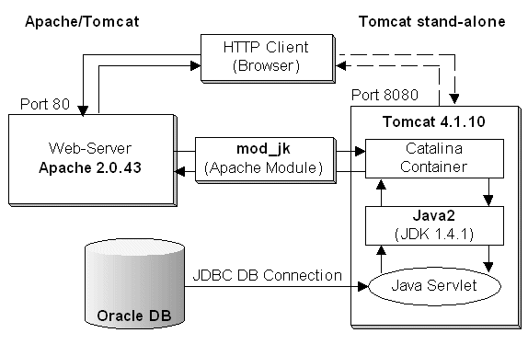

Fig 1.1 Apache Tomcat internal architecture

Apache Tomcat (Tomcat Server) is an open-source Java Servlet Container that implements several Java EE specifications including Java Servlet, Java Server Pages (JSP) and provides a pure Java HTTP web server environment in which Java code can run.

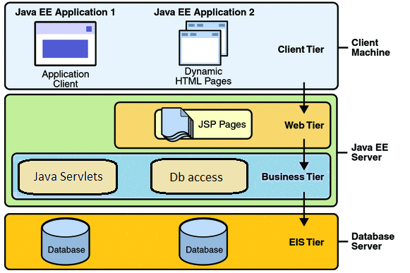

Fig 1.2.1 Software Architecture

A web application is an application that can be accessed by users through web browsers like Google Chrome, Internet Explorer, Safari, etc., or a specialized user agent. Browsers request for specific URLs that will map the resources on a Web server. Servers render and return HTML pages to the client, which the browsers will display to the users. The core of the web application is the server-side logic. The application can contain several distinct layers.

A web application is typically a three-layered architecture comprised of the presentation, business and data layers.

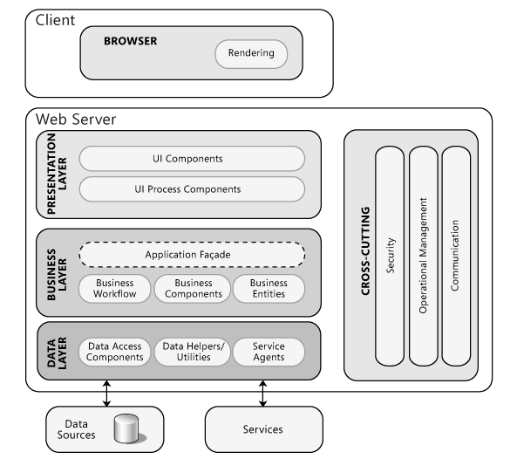

Fig 1.2.2 Working of a Software Architecture

Level 1 – Client

The client is basically the browser, i.e., the web server that serves pages. It provides an interface between the user and the application processing server. Client requests for services and Servers processes the requests to provide for services.

LEVEL 2 – SERVER

The server is a three-tier layer consisting of the presentation layer, business layer and the data layer.

* Presentation Layer – This layer consists of user oriented functionality that is responsible for managing user interaction with the system. It generally consists of components that provide a common bridge into the core business logic encapsulated in the business layer with the web page or an operating system’s GUI.
* Business Layer – This layer implements the core functionalities of the system and encapsulates business logic. It consists of components that may expose some of the components of the service interface that other callers may use. It mainly controls application functionality.
* Data Layer – This layer provides access to data hosted within the boundaries of the system and data exposed by other systems. It should provide an API to the application tier that exposes methods of managing stored data without exposing or creating dependencies on the data storage mechanisms. Avoiding dependencies on the storage mechanism allows for updates or changes to be performed without changing the application tier clients.

# System Design

4.1 Flowchart of how the application works

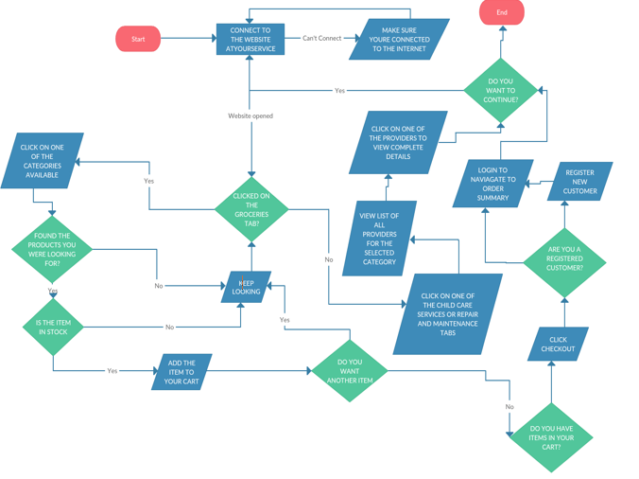

Fig 1.3 Flow diagram of the implementation of the website.

4.2 User Stories

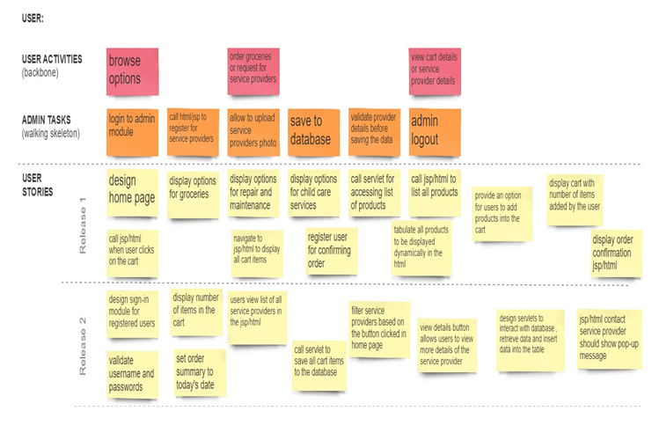

Fig 1.4 User story board

4.3 UI Mock-up Screens

4.3.1 Home Page

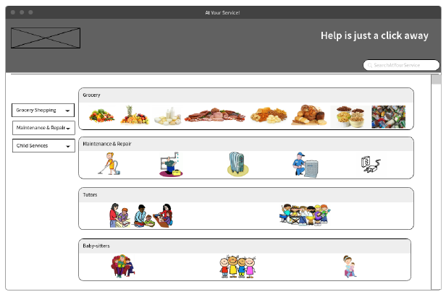 Fig 1.5

4.3.2 Grocery Details Page

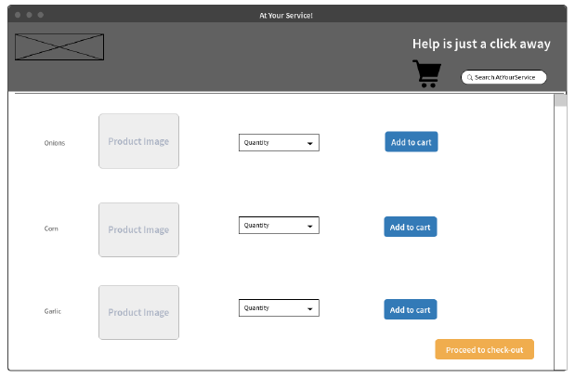

Fig 1.6

4.3.3 Login Page

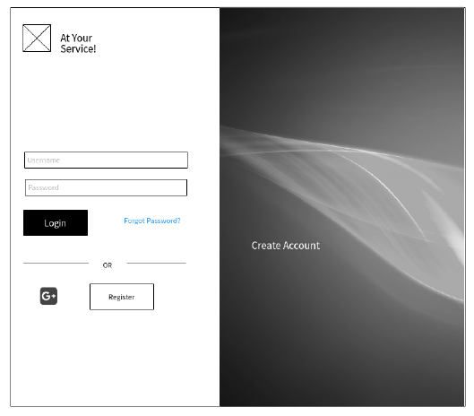

Fig 1.7

4.3.4 Register Page

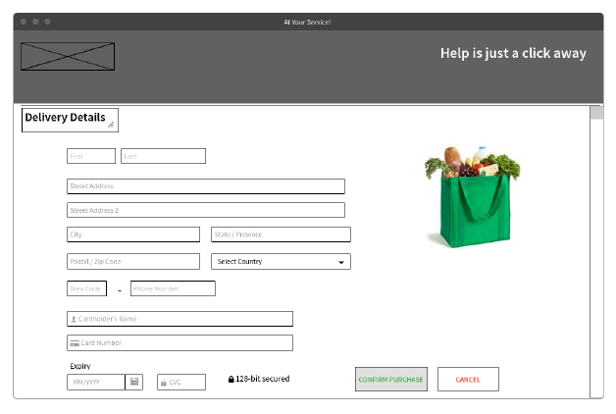

Fig 1.8

4.3.5 Order Confirmation Page

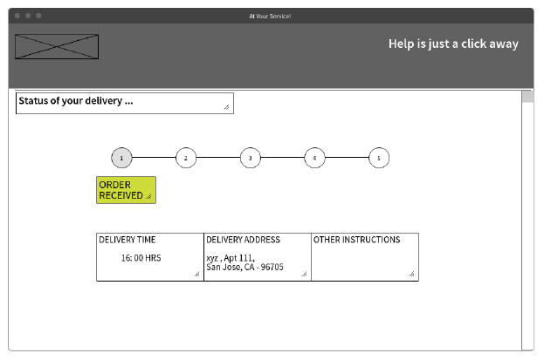

Fig .19

4.3.6 Project Implementation Screen shots

4.3.6.1 Home Page

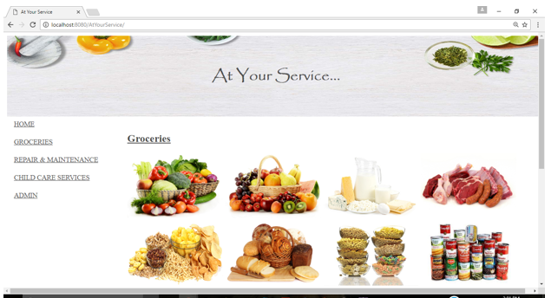

4.3.6.2 Child Care Services – Tutors

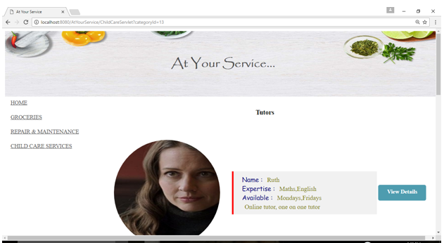

4.3.6.2-1 Tutors View Details Page & Contact Provider Details

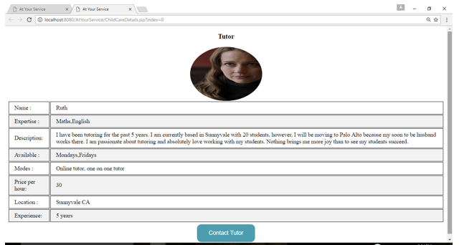

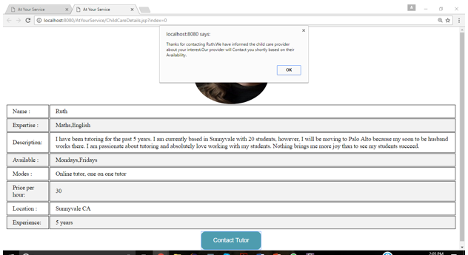

4.3.6.2-2 Child Care Services – Baby Sitters

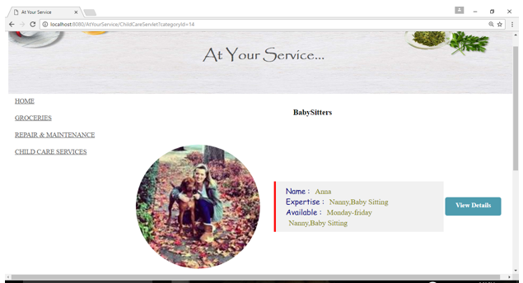

4.3.6.3-1 Repair & Maintenance – Housekeeping

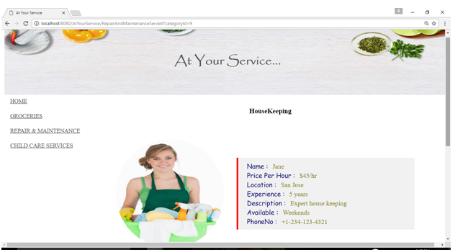

4.3.6.3-2 Repair & Maintenance – Plumbing

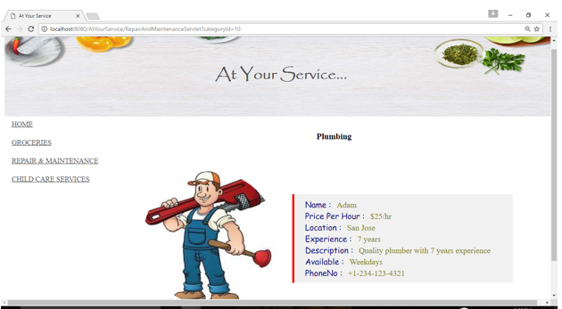

4.3.6.3-3 Repair & Maintenance – Heating & Cooling

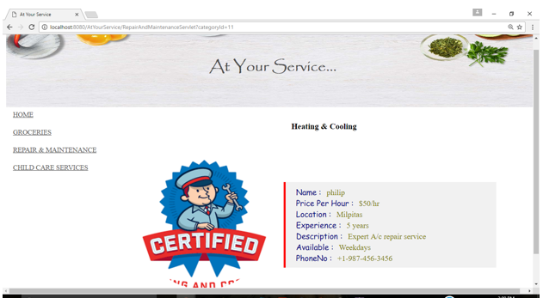

4.3.6.3-4 Repair & Maintenance – Electric

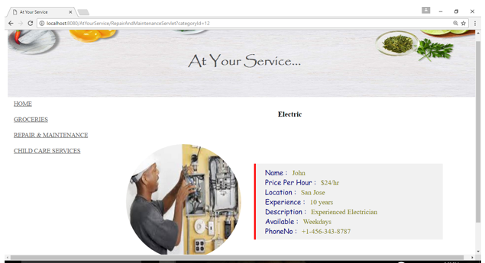

4.3.6.4-1 Groceries – Vegetables

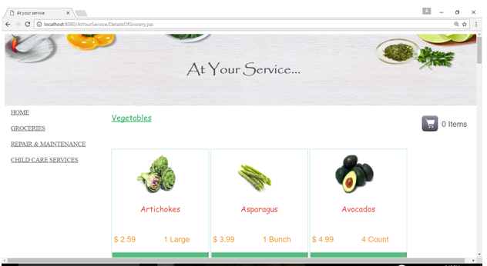

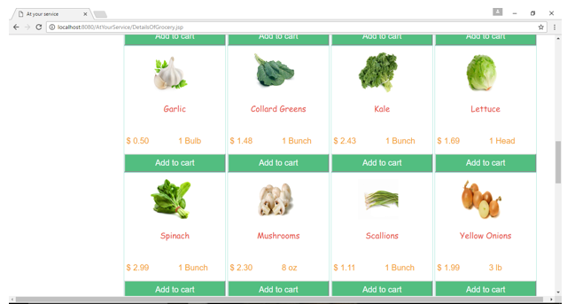

4.3.6.4-2 Groceries – Fruits

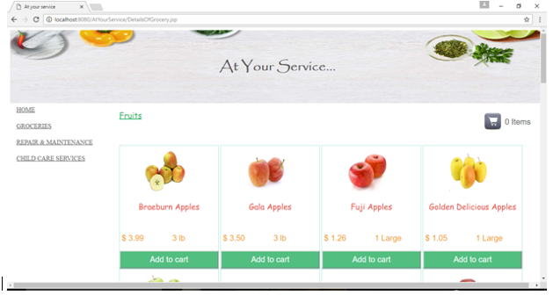

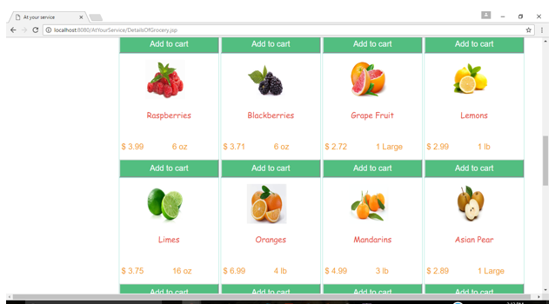

4.3.6.4-3 Groceries – Dairy Products

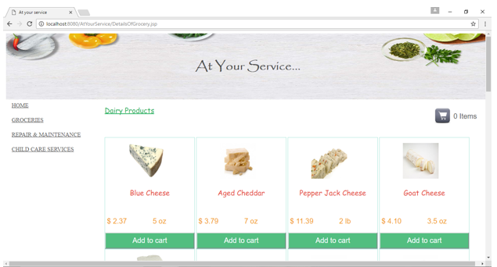

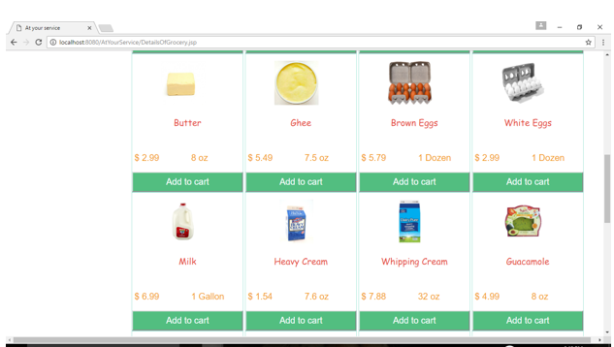

4.3.6.4-4 Groceries – Meat

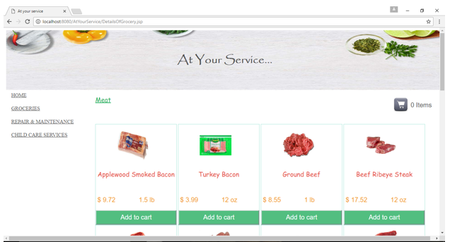

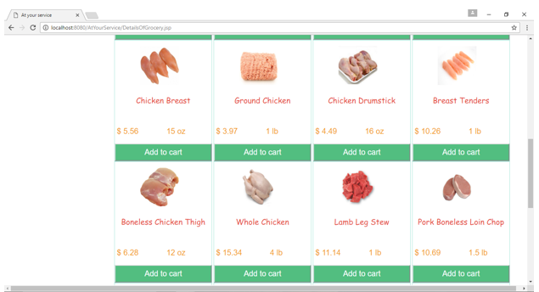

4.3.6.4-5 Groceries – Snacks

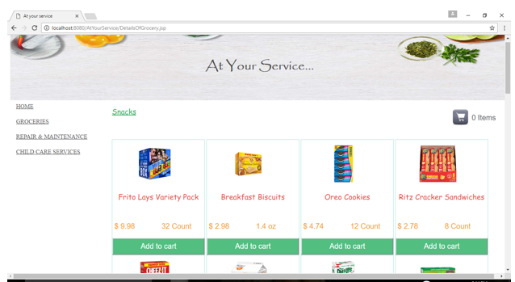

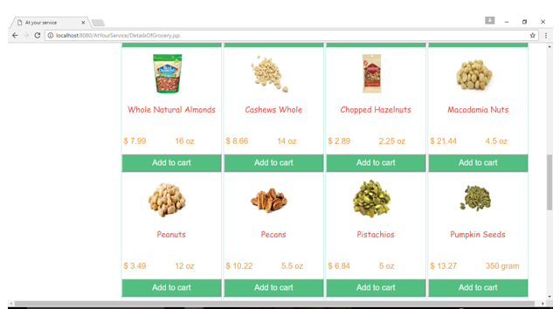

4.3.6.4-6 Groceries – Bread & Bakery

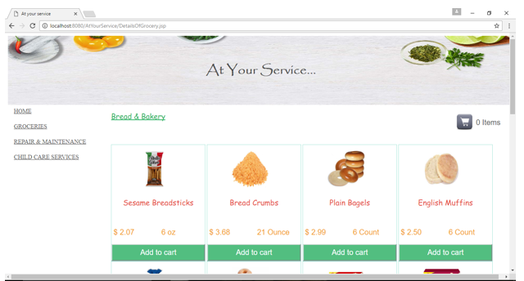

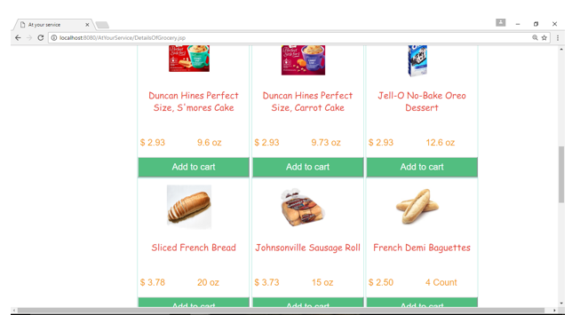

4.3.6.4-7 Groceries – Cereal

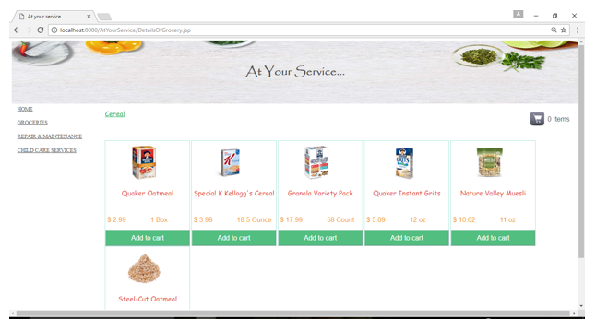

4.3.6.4-8 Groceries – Canned & Packed Foods

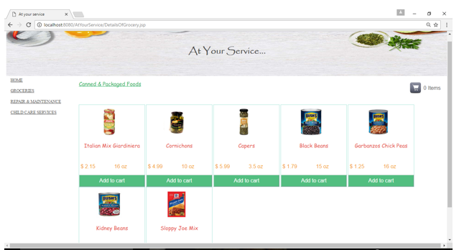

4.3.6.5 Groceries- Cart Details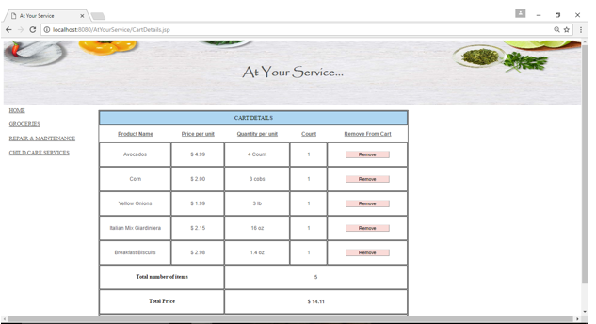

4.3.6.6 Groceries – Checkout (Sign in and Signup)

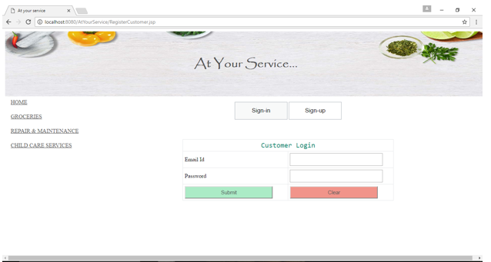

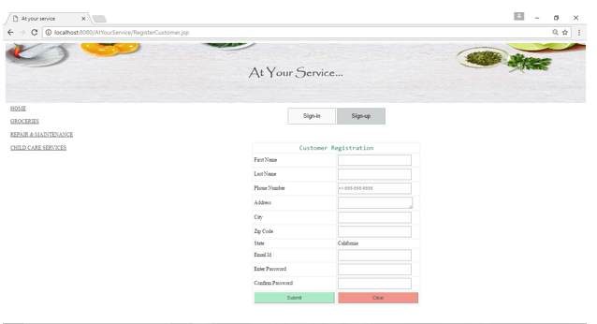

4.3.6.7 Groceries-Order Confirmation Page

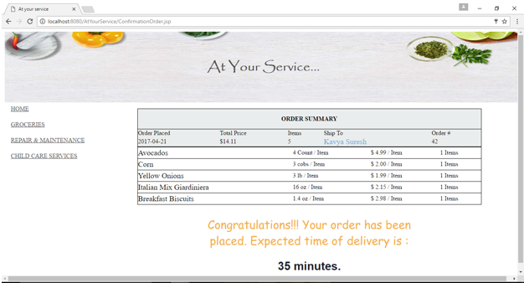

4.3.6.8 Admin Module

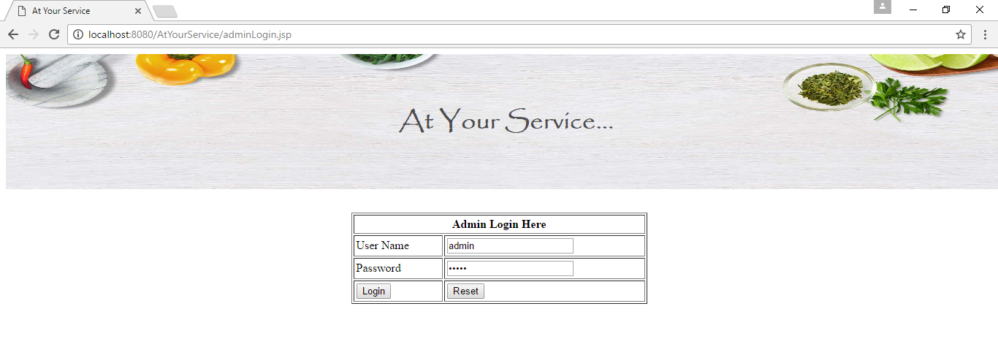

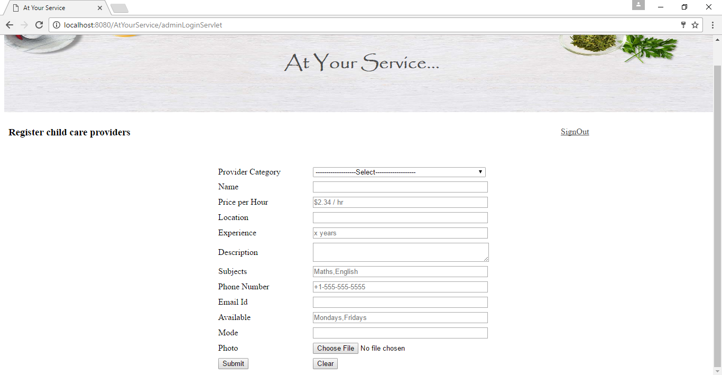

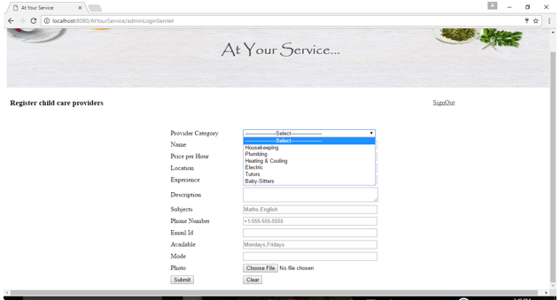

# Implementation

* 1. New frameworks, languages, or technologies

# Frameworks

* Servlet API.
* Java Server Pages.
* Apache Tomcat.
* HTML.
* CSS and JavaScript.
* Java Persistence API.
* MySQL Workbench 6.3
* Apache Tomcat 8.0

LANGUAGES

* Java
* JavaScript
* HTML
* CSS
  1. Tools and Component Reuse

The tools and components that have been used and reused in this project are –

* Eclipse Luna Java 8 – to develop a dynamic web application in java.
* Apache Tomcat 8.0 – server host to run the web application.
* mysql-connector-java-5.1.38-bin.jar – this jar allows the dynamic web application to connect to the database to exchange data.
* GitHub – to save, merge and update code.

# Testing

* 1. Unit Test Cases

|  |  |  |  |  |
| --- | --- | --- | --- | --- |
| TEST CASES | DESCRIPTION / OBJECTIVE | PRE-CONDITIONS | EXPECTED RESULT | RESULT |
| TC01 | Loading home page | User enters the URL of the website to be loaded. | Run the URL <http://localhost:8080/AtYourService> in the browser loads the home page. | Pass |
| TC02 | Clickable Hyperlinks in home page. | Home page is loaded. | User is able to click on one of the links in the Menu page. | Pass |
| TC03 | Select a category from one of the dropdowns. | User clicks on one of the hyperlinks in the home page. | 1. User clicks on a menu hyperlink.  2. A dropdown list of all sub-categories is displayed.  3. User clicks on one of the sub-categories on the list.  4. User is navigated to a landing page with a list of all featured products. | Pass |
| TC04 | Display product details (Product Image, Product Name, Price and Quantity) on product page load. | User is navigated to list of products page. | List of all products, for example say Dairy Products, is displayed in a tabular form.  Product Image, below which product name, price and quantity sold is displayed.  Each product is attached with an Add to Cart Button. | Pass |
| TC05 | Click on the Add to Cart Button. | User views a list of product and product details. | Product is added to the cart. | Pass |
| TC06 | User can navigate between pages without error. | User is browsing the website. | User clicks on different tabs on the home page or other pages he has navigated to. | Pass |
|  |  |  |  |  |
| TC07 | User clicks on the cart icon on the Groceries page. | User has added items to the cart. | User is navigated to the Cart details page, where details of all the products added to the cart are displayed. | Pass |
| TC08 | User clicks on Remove button in the Details page. | There are at least 1 or more items in the cart. | The product the user wants to remove is deleted from the cart. | Pass |
| TC09 | User clicks on Proceed to checkout button. | There is at least one item left in the cart. | User is navigated to the Login / Register page. | Pass |
| TC10 | User clicks on the Sign-Up tab in the Login and Register page. | User has clicked on Proceed to Checkout button. | Register Customer form is displayed. | Pass |
| TC11 | User enters all valid details in the input columns to register a customer and clicks on Submit. | User has clicked on the Sign-up tab. | User is registered successfully and user is navigated to the Sign-in tab with a success message displayed for login. | Pass |
| TC12 | User enters a password that does not meet required criteria. | User has entered all the details for registering and clicked on submit button. | Error message " Password must be at least 8 characters with one special character, one uppercase letter, one lowercase letter and one number and not be same as email" must be displayed and user is not allowed to register | Pass |
| TC13 | User enters an email id that is not valid for registration. | User has entered all the details for registering and clicked on submit button. | Error message “E-mail entered is invalid” must be displayed and User is not allowed to register | Pass |
| TC14 | User Logins in from the Sign-in page with valid credentials. | User has successfully registered. | User is navigated to the order confirmation page to view his order summary. | Pass |
| TC15 | User enters invalid credentials for login. | User is successfully registered. | Error message “E-mail or password entered is invalid” must be displayed to the user and user is not allowed to login. | Pass |
| TC16 | Admin has successfully logged into the application. | Admin has browsed the website. | Admin is navigated to the Register service provider page. | Pass |
| TC17 | Admin registers a service provider by entering valid credentials of the provider. | Admin has logged into the admin module successfully. | A success message “Provider registered successfully is displayed” | Pass |

# Modifications of the Original Plan

Though the original plan was to include a payment system for the user to pay for the groceries, the plan was dropped dude to security issues in saving the card details in the database.

Also, I was unable to integrate the PayPal API into my existing application, thus modifying my original plan of integrating the payment system.

Instead of Single-sign-on (SSO), I created my own Register User Page and decided to implement MD5 hashing algorithm to save passwords in an encrypted fashion in my data base.

# SCOPE

* Payment module.
* Google map for grocery drop route.
* Confirmation e-mail sent to users for grocery order.
* Details about provider e-mails sent to user upon request.
* Calendar integration to confirm schedules for tutors, baby-sitters, and repair and maintenance users.
* Edit and Delete Service care providers by Admin.

# Conclusions and Lessons Learned

The project described in this report was developed according to a carefully designed processes and ideas. As web developers, we are trying hard to solve issues that arise due to inconsistencies between rendering web pages by different browsers. Reducing code does not necessarily mean reducing functionalities, it avoids double coding or multiple coding. A single Java Server Page (JSP) can be reused to display different data. This is known as code reuse.

Writing web pages according to standards site development time and makes pages easier to maintain. Debugging and troubleshooting becomes easier. Universal adoption of web standards is becoming important. Its mission is to make the web a safer place for developers, end-users, testers by making them follow coding standards. The importance of securing the database to prevent hacking or information leak is vital.

# References

1. User Story board - <https://realtimeboard.com/app/>
2. UI Mockup plans - <https://moqups.com/>
3. System design flowchart - <https://creately.com/app>
4. System architecture - <https://msdn.microsoft.com/en-us/library/ee658099.aspx>
5. Client server architecture - <https://en.wikipedia.org/wiki/Client%E2%80%93server_model>

<http://ccm.net/contents/151-networking-3-tier-client-server-architecture>

1. Website design plan - <https://www.amazon.com/AmazonFresh/b?ie=UTF8&node=10329849011>
2. HTML, CSS tutorials - <https://www.w3schools.com/>
3. MySQL database tutorials - <https://www.tutorialspoint.com/mysql/mysql-data-types.htm>
4. GitHub tutorials - <http://product.hubspot.com/blog/git-and-github-tutorial-for-beginners>
5. Documentation standards - <http://www.ofnisystems.com/services/validation/user-requirement-specifications/>